Robert Eriksson & Seth Pech
Table tennis clinic June 9-10 at Experior Table Tennis Club
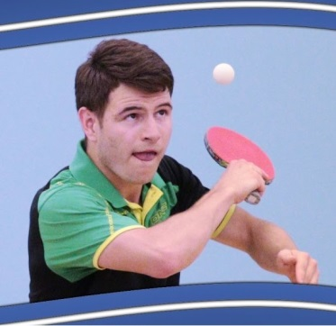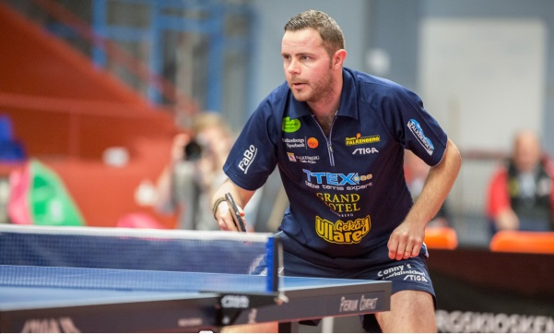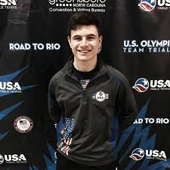
Develop your game during two full days together with professional player
Robert Eriksson from Sweden and the future star Seth Pech from Ohio.
Robert Eriksson
- Professional player in the Swedish, French, Danish Super Leagues for 13 years
- Sweden National Championships Men’s Singles Bronze Medalist
- Sweden National Championships Men’s Doubles Bronze Medalist
- Sweden National Championships Men´s Teams Silver Medalist
- Defeated world class players Marcos Freitas, Mattias Karlsson, Kou Lei, Cho Eon Rae, Jörgen Persson
Seth Pech
- Number 1 player in Ohio, March 2018
- 12th out of 16 players in the National Team trials 2018
- Semi-finalist u2500 US Open 2017
- Coaching students for more than 10 years
About the clinic
- Three sessions Saturday 3*2,5h, two sessions Sunday 2*2,5h
- 1 topic for each session (5 topics total)
- Every session will include:
- Individual drills for every player
- Multi-ball practice with one of the coaches for every player
- Individual attention and advices from the coaches
- Lectures about each topic and how to use it in game situations
- Exhebition how to play each drill and how to think playing each drill
Costs
- $55/session, $150/Saturday, $100/Sunday, $225/both days (cash only)
For more information contact Arcot Naresh or send an e-mail to one of the coaches eriksson_robert@hotmail.com or sethdan1995@googlemail.com

